
Proverbs 16:3 & Romans 10:9
RED LION YOUTH FOOTBALL
Age 12-13 Division 2026 – Teams should arrive 1 hour prior to their game for practice
Everyone must play at least 50% of the Game * THINK POSITIVE BE POSITIVE
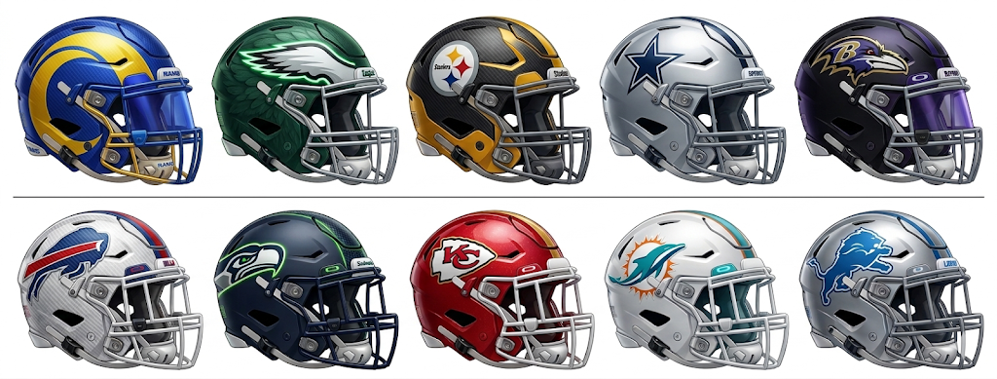
Date Time Home Team Away Team Field
Week 1 - * ARRIVE 1 hour prior to your game for practice * THINK POSITIVE BE POSITIVE!
- Sun 3/29/2026 5:00 pm Steelers vs. Eagles #1 - Stadium
- Sun 3/29/2026 5:00 pm Seahawks vs. Bills #2 – Stadium
- Sun 3/29/2026 5:00 pm Cowboys vs. Lions #3 – Turf
- Sun 3/29/2026 5:00 pm Ravens vs. Chiefs #5- Turf
- Sun 3/29/2026 6:00 pm Rams vs. Dolphins #6- Grass

4/5/26 WE are off on Easter Sunday * Happy Easter and Resurrection DAY!
We wish you and your families a very Happy Easter and a meaningful Resurrection Day. We look forward to seeing everyone back and energized next week!


Proverbs 16:3 & Romans 10:9
RED LION YOUTH FOOTBALL
Age 12-13 Division 2026 – Teams should arrive 1 hour prior to their game for practice
Everyone must play at least 50% of the Game * THINK POSITIVE BE POSITIVE
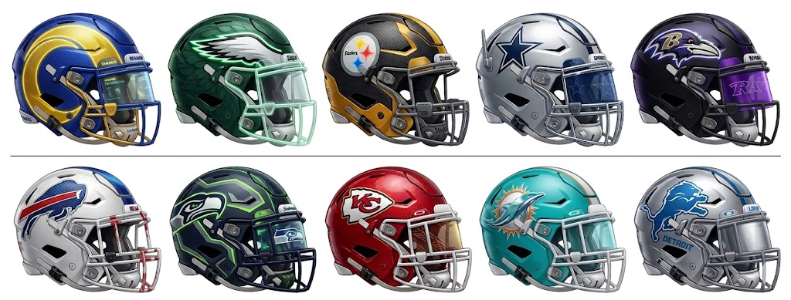

Week 2 * ARRIVE 1 hour prior to your game for practice * THINK POSITIVE BE POSITIVE!
- Sun 4/12/2026 5:00 pm Steelers vs. Rams #1 - Stadium
- Sun 4/12/2026 5:00 pm Eagles vs. Seahawks #2 – Stadium
- Sun 4/12/2026 5:00 pm Bills vs. Chiefs #3 – Turf
- Sun 4/12/2026 5:00 pm Dolphins vs. Cowboys #5- Turf
- Sun 4/12/2026 6:00 pm Lions vs. Ravens #6- Grass

Week 3 * ARRIVE 1 hour prior to your game for practice * THINK POSITIVE BE POSITIVE !
- Sun 4/19/2026 5:00 pm Ravens vs. Dolphins #1 - Stadium
- Sun 4/19/2026 5:00 pm Steelers vs. Cowboys #2 – Stadium
- Sun 4/19/2026 5:00 pm Eagles vs. Rams #3 – Turf
- Sun 4/19/2026 5:00 pm Bills vs. Lions #5- Turf
- Sun 4/19/2026 6:00 pm Seahawks vs. Chiefs #6- Grass

Proverbs 16:3 & Romans 10:9
RED LION YOUTH FOOTBALL
Age 12-13 Division 2026 – Teams should arrive 1 hour prior to their game for practice
Everyone must play at least 50% of the Game * THINK POSITIVE BE POSITIVE
Date Time Home Team Away Team Field
Week 4 * ARRIVE 1 hour prior to your game for practice * THINK POSITIVE BE POSITIVE !
- Sun 4/26/2026 5:00 pm Dolphins vs. Bills #1 - Stadium
- Sun 4/26/2026 5:00 pm Lions vs. Seahawks #2 – Stadium
- Sun 4/26/2026 5:00 pm Cowboys vs. Rams #3 – Turf
- Sun 4/26/2026 5:00 pm Eagles vs. Chiefs #5- Turf
- Sun 4/26/2026 6:00 pm Steelers vs. Ravens #6- Grass

Week 5 * ARRIVE 1 hour prior to your game for practice * THINK POSITIVE BE POSITIVE!
- Sun 5/3/2026 5:00 pm Rams vs. Ravens #1 - Stadium
- Sun 5/3/2026 5:00 pm Chiefs vs. Lions #2 – Stadium
- Sun 5/3/2026 5:00 pm Seahawks vs. Dolphins #3 – Turf
- Sun 5/3/2026 5:00 pm Bills vs. Steelers #5- Turf
- Sun 5/3/2026 6:00 pm Cowboys vs. Eagles #6- Grass

*WE ARE OFF ON 5/10/26 HAPPY MOTHER’S DAY! HOPE ALL OF OUR MOM’s HAVE THE BEST DAY EVER!
We want to take this opportunity to wish all of our mothers and grandmothers a very Happy Mother’s Day! We hope you have a wonderful day of celebration and relaxation with your families!

Proverbs 16:3 & Romans 10:9
RED LION YOUTH FOOTBALL
Age 12-13 Division 2026 – Teams should arrive 1 hour prior to their game for practice
Everyone must play at least 50% of the Game * THINK POSITIVE BE POSITIVE
Date Time Home Team Away Team Field

Week 6 * ARRIVE 1 hour prior to your game for practice * THINK POSITIVE BE POSITIVE!

- Sun 5/17/2026 5:00 pm Cowboys vs. Ravens #1 - Stadium
- Sun 5/17/2026 5:00 pm Dolphins vs. Chiefs #2 – Stadium
- Sun 5/17/2026 5:00 pm Eagles vs. Lions #3 – Turf
- Sun 5/17/2026 5:00 pm Rams vs. Bills #5- Turf
- Sun 5/17/2026 6:00 pm Seahawks vs. Steelers #6- Grass

Everyone must play at least 50% of the Game * THINK POSITIVE BE POSITIVE

* WE ARE OFF ON 5/26/25 – HAPPY MEMORIAL DAY WEEKEND. THANK YOU TO ALL WHO SERVED, and THANK YOU TO ALL OF THOSE WHO GAVE THE ULTIMATE PRICE FOR OUR FREEDOM!


Proverbs 16:3 & Romans 10:9
RED LION YOUTH FOOTBALL
Age 12-13 Division 2026 – Teams should arrive 1 hour prior to their game for practice
Everyone must play at least 50% of the Game * THINK POSITIVE BE POSITIVE
Date Time Home Team Away Team Field
Week 7 * Round 1 of the Playoffs - ALL TEAMS ADVANCE TO FINAL WEEK: 6/7/26
Everyone must play at least 50% of the Game * THINK POSITIVE BE POSITIVE
- Sun 5/31/2026 5:00 pm Seed 1 vs. Seed 4 #1 – Stadium
(Winner of Game 31 advances to the Super Bowl on 6/8)
(Non-Winning Team will play Non-Winning team of Game 32 in the D1 Championship on 6/8)

- Sun 5/31/2026 5:00 pm Seed 2 vs. Seed 3 #2 – Stadium
(Winner of Game 32 advances to the Super Bowl on 6/8)
(Non-Winning Team will play Non-Winning team of Game 31 in the D1 Championship on 6/8)

- Sun 5/31/2026 5:00 pm Seed 10 vs. Seed 5 #3 – Turf
- Sun 5/31/2026 5:00 pm Seed 9 vs. Seed 6 #5- Turf
- Sun 5/31/2026 6:00 pm Seed 7 vs. Seed 8 #6- Grass

For Week 6/7/26 ---- EVERYONE PLAYS! All Teams advance to a FINAL GAME.
Games 33 through 35:
Highest seeds will play each other: Blue/Gold Championship
Highest seeds thereafter will play each other: Diamond State Championship
Highest remaining seeds will play each other: Blue Hen Conference Championship
ALL TEAMS ADVANCE TO FINAL WEEK: 6/7/26
Proverbs 16:3 & Romans 10:9
RED LION YOUTH FOOTBALL
Age 12-13 Division 2026 – Teams should arrive 1 hour prior to their game for practice
Everyone must play at least 50% of the Game * THINK POSITIVE BE POSITIVE

Date Time Home Team Away Team Field

Week 8 - Final Week - Championships and Awards - highest remaining seed play for Championship
- Sun 6/7/2026 5:00 pm Two Highest seeds: Superbowl #1 - Stadium
- Sun 6/7/2026 5:00 pm Division I Championship #2 – Stadium
- Sun 6/7/2026 5:00 pm Blue Gold Championship #3 – Turf
- Sun 6/7/2026 5:00 pm Diamond State Championship #5- Turf
- Sun 6/7/2026 6:00 pm Blue Hen Conference Championship #6- Grass

Everyone must play at least 50% of the Game * THINK POSITIVE BE POSITIVE

THANK YOU FOR BEING A PART OF OUR LEAGUE!
May God bless you and your family!
